RPiExtension

Risk List

Version <1.0>

Revision History

|  |  |  |  |
| --- | --- | --- | --- |
| **Date** | **Version** | **Description** | **Author** |
| 24/Oct/21 | 1.0 | Initialize | Altay Brusan |
|  |  |  |  |
|  |  |  |  |
|  |  |  |  |

Table of Contents

1. Introduction 4

1.1 Purpose 4

1.2 Scope 4

1.3 Definitions, Acronyms, and Abbreviations 4

1.4 References 4

1.5 Overview 4

2. Risks 4

2.1 USB_PROTECT 4

2.1.1 Risk Magnitude or Ranking 4

2.1.2 Description 4

2.1.3 Impacts 4

2.1.4 Indicators 4

2.1.5 Mitigation Strategy 4

2.1.6 Contingency Plan 4

2.2 MIC_SD_HOUSING 5

2.2.1 Risk Magnitude or Ranking 5

2.2.2 Description 5

2.2.3 Impacts 5

2.2.4 Indicators 5

2.2.5 Mitigation Strategy 5

2.2.6 Contingency Plan 5

2.3 INACCUR_FOOTPRN 5

2.3.1 Risk Magnitude or Ranking 5

2.3.2 Description 5

2.3.3 Impacts 5

2.3.4 Indicators 5

2.3.5 Mitigation Strategy 5

2.3.6 Contingency Plan 5

2.4 TEMP_LIMT 6

2.4.1 Risk Magnitude or Ranking 6

2.4.2 Description 6

2.4.3 Impacts 6

2.4.4 Indicators 6

2.4.5 Mitigation Strategy 6

2.4.6 Contingency Plan 6

Risk List

# Introduction

This document includes the purpose, scope, definitions, acronyms, abbreviations, references, and overview of this **Risk List**.

## Purpose

Analyze the risks associated with RpiExt.

## Scope

The project associated with this document is RpiExt circuit design.

## Definitions, Acronyms, and Abbreviations

RPiExt: Rpi Extension card. Raspberry Pi 4 module card.

## References

Board datasheet:

https://datasheets.raspberrypi.com/cm4io/cm4io-datasheet.pdf

## Overview

In the following the risks that could directly affect on the project progress and its success are enlisted. The technical detailed risks are not included.

# Risks

## USB_PROTECT

### Risk Magnitude or Ranking

Low

### Description

The USB device can damage the board with static charge.

### Impacts

could cause permanent or serious damages to the circuit.

### Indicators

The USB ports do not work

### Mitigation Strategy

Design special protection circuit to avoid hazard.

### Contingency Plan

replace the circuit.

## MIC_SD_HOUSING

### Risk Magnitude or Ranking

Low

### Description

Liquid could leak into the box through the MicroSD cad housing.

### Impacts

could cause permanent or serious damages to the circuit.

### Indicators

Corrosion

### Mitigation Strategy

By design: design a waterproof housing.

### Contingency Plan

replace the circuit or MicroSD socket

## INACCUR_FOOTPRN

### Risk Magnitude or Ranking

Medium

### Description

The RPI COM 4 module, footprint in IO board does not match with the modules’ guide line in the datasheet.

### Impacts

The designed board may not work.

### Indicators

The designed circuit does not work properly or boot up.

### Mitigation Strategy

Insert optional jumpers in PCB design. These jumpers let testers to select among different options.

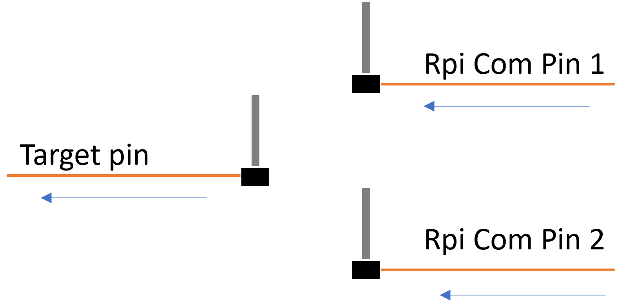

### Contingency Plan

redesign the circuit.

## TEMP_LIMT

### Risk Magnitude or Ranking

Medium

### Description

The environment temperature may exceed the range in which the system works.

### Impacts

could cause the data lost.

### Indicators

system could reset automatically.

### Mitigation Strategy

select components that works in the range of the target environment and considering cooling fan in the system.

### Contingency Plan

cool down the system.